Practical No: 7
Aim: Implement a wireless sensor network simulation.

Steps:
- Take one AccessPoint-PT-A and two PC-PT.
- Click on PC0 and click on Physical tab.
- Turn off the CPU and remove the FastEthernet module and install PT-HOST-NM-1W-A and turn On the CPU.

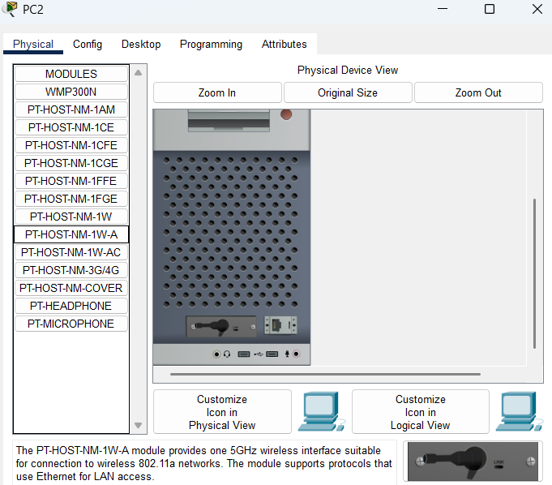

- A connection will be made between Accesspoint and PC0.
- Click on PC1 and click on physical tab.
- Repeat step 3 and see if the connection is done between PC1 and Accesspoint.
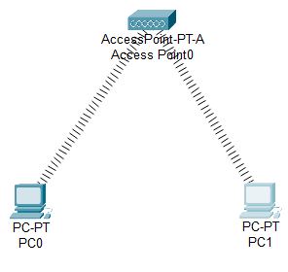

- Click on PC0 goto Desktop > IP config.
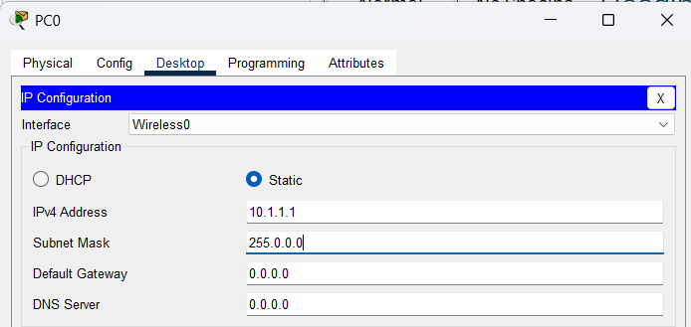
Set IP configuration to static and IP address: 10.1.1.1
- Click on PC1 goto Desktop > IP config.
Set IP configuration to static and IP address: 10.1.1.2
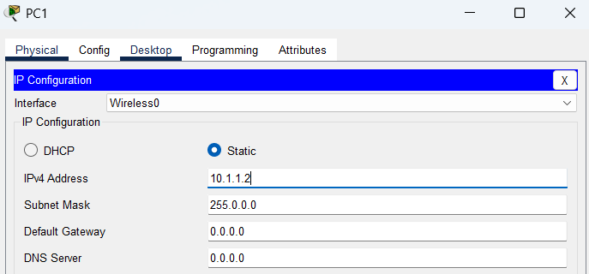

- Test Access PointA
a. Ping PC1 (10.1.1.2) from PC0. The ping should succeed.
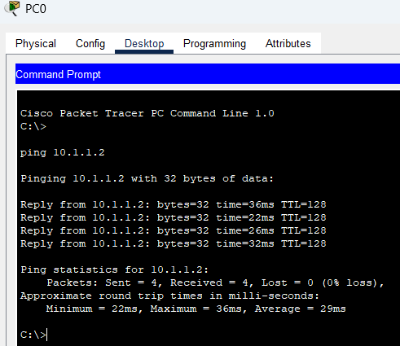

- Take one Accesspoint-PT , Accesspoint-PT-N , Laptop and Server.
- Click on Laptop and click on Physical tab.
- Turn off the Laptop and remove the PT-LAPTOP-NM-1CFE module and install PT LAPTOPNM-1W and turn On the Laptop.
- A connection will be made between Accesspoint-PT-N and Laptop.
- Click on Laptop go to Desktop > IP config.
Set IP configuration to static and IP address to 10.1.1.3
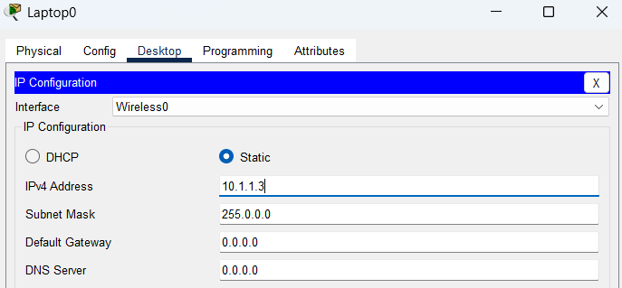

- Click on Server and click on Physical tab.
- Turn off the Server and remove the PT-HOST-NM-1CFE module and install PT-HOST-NM-1W and turn On the Server.
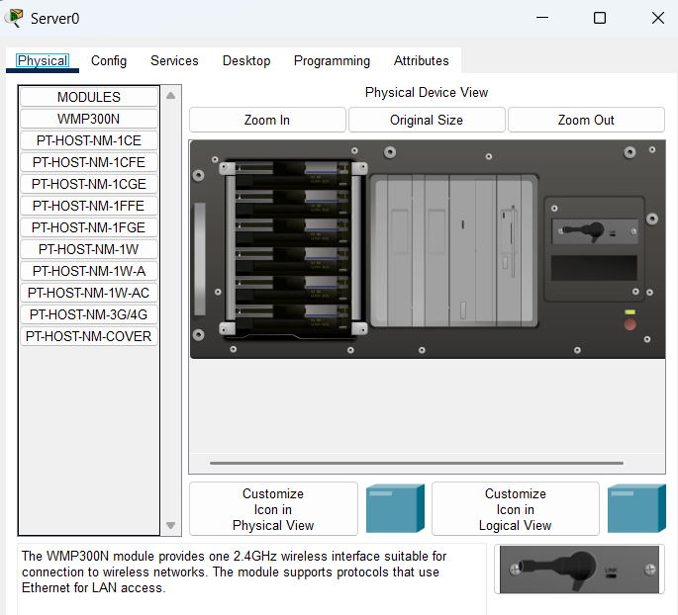
- A connection will be made between Accesspoint-PT-N and Server.
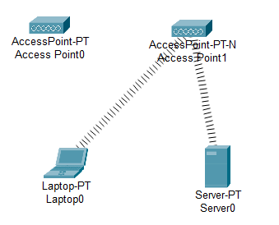

- Click on Server goto Desktop > IP config.
Set IP Configuration to static and IP address to 10.1.1.4
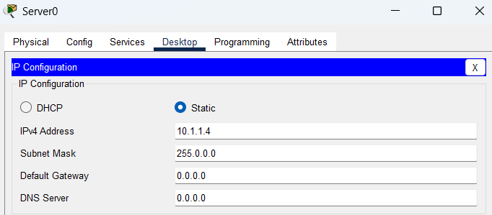
- Test Access PointN
- Ping Server0 (10.1.1.4) from Laptop0. The ping should succeed.
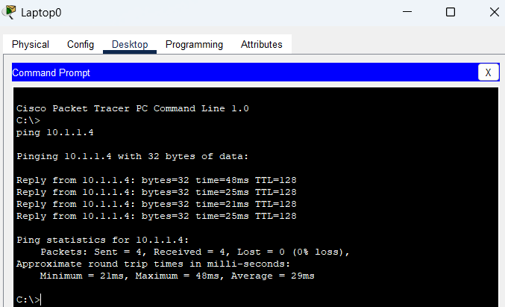
- Ping PC0 (10.1.1.1) and PC1 (10.1.1.2) from Laptop0. The pings should fail.
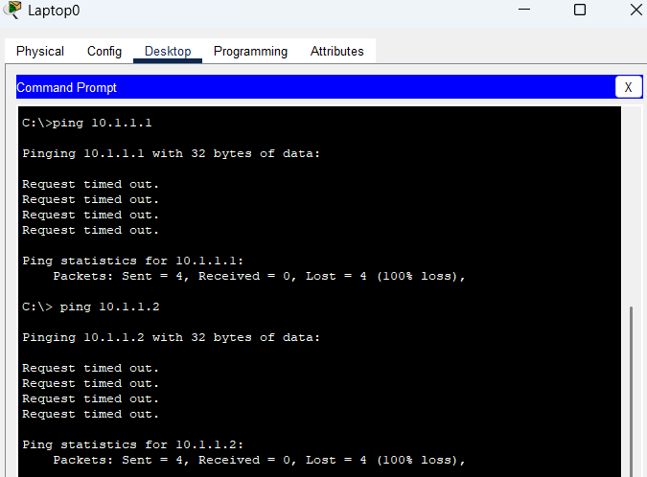

20. Now Turn off the port of Accesspoint-PT-N and Test Accesspoint PT
a. Turn on Port1 on Accesspoint PT and turn off Port1 on Accesspoint-PT-N.
Laptop0 and Server0 should connect with Accesspoint PT
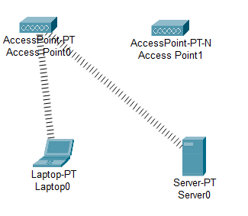

- Ping Server0 (10.1.1.4) from Laptop0. The ping should succeed.
